Spring Boot資料庫圖片下載顯示:
pom.xml
<dependency>
<groupId>org.springframework.boot</groupId>
<artifactId>spring-boot-starter-data-jpa</artifactId>
</dependency>
<dependency>
<groupId>org.springframework.boot</groupId>
<artifactId>spring-boot-starter-thymeleaf</artifactId>
</dependency>
<dependency>
<groupId>org.springframework.boot</groupId>
<artifactId>spring-boot-starter-web</artifactId>
</dependency>
<dependency>
<groupId>com.mysql</groupId>
<artifactId>mysql-connector-j</artifactId>
<scope>runtime</scope>
</dependency>

application.properties JPA 連線設定

spring.datasource.url=jdbc:mysql://localhost:3306/mydb
spring.datasource.username=root
spring.datasource.password=1234

spring.jpa.hibernate.ddl-auto=create-drop

logging.level.org.springframework.security=DEBUG
spring.jpa.show-sql=true
spring.jpa.properties.hibernate.format_sql=true

spring.datasource.hikari.connection-init-sql=SET GLOBAL max_allowed_packet=10240000
spring.servlet.multipart.max-file-size=10MB
spring.servlet.multipart.max-request-size=10MB

Model Entity:

import jakarta.persistence.*;
import java.io.*;
import java.util.*;
@Entity
@Table(name = "uploadproducts")
public class Product implements Serializable {

@Id
@Column(name = "Code", length = 20, nullable = false)
private String code;

@Column(name = "Name", length = 255, nullable = false)
private String name;

@Column(name = "Price", nullable = false)
private double price;

@Lob
@Column(name = "Image", length = Integer.MAX_VALUE, nullable = true)
private byte[] image;

@Temporal(TemporalType.TIMESTAMP)
@Column(name = "Create_Date", nullable = false)
private Date createDate;

public Product() {
}

public String getCode() {
return code;
}

public void setCode(String code) {
this.code = code;
}

public String getName() {
return name;
}

public void setName(String name) {
this.name = name;
}

public double getPrice() {
return price;
}

public void setPrice(double price) {
this.price = price;
}

public Date getCreateDate() {
return createDate;
}

public void setCreateDate(Date createDate) {
this.createDate = createDate;
}

public byte[] getImage() {
return image;
}

public void setImage(byte[] image) {
this.image = image;
}
@Override
public String toString() {
return "Product [code=" + code + ", name=" + name + ", price=" + price + ", createDate=" + createDate + "]";
}
}

測試一下是否能產生臨時資料
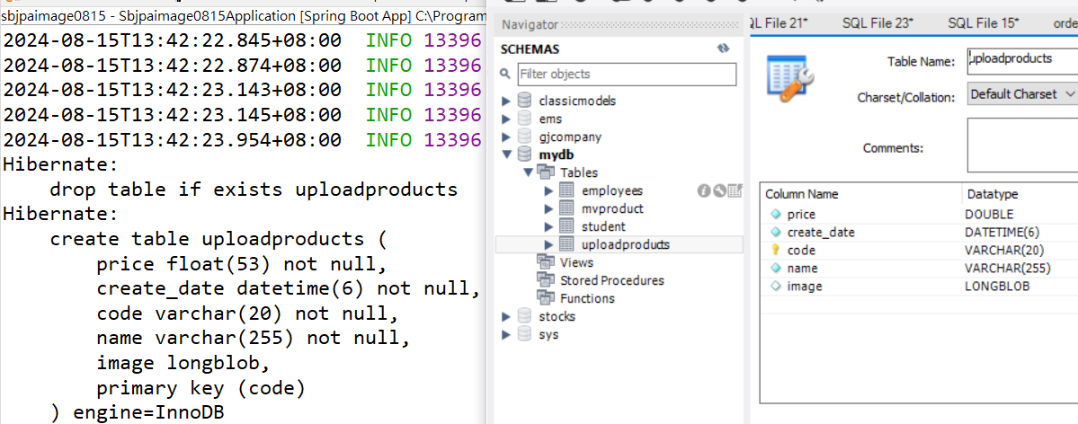
ProductRepository.java
import org.springframework.data.jpa.repository.JpaRepository;
public interface ProductRepository extends JpaRepository<Product, String>{

}

Service 程式:
import java.util.*;
import org.springframework.beans.factory.annotation.Autowired;
import org.springframework.data.domain.Page;
import org.springframework.data.domain.PageRequest;
import org.springframework.data.domain.Pageable;
import org.springframework.data.domain.Sort;
import org.springframework.stereotype.Service;

@Service
public class ProductDAO {
@Autowired
ProductRepository dao;

public Product save(Product p) {
return dao.save(p);
}
public Product findProduct(String code) {
Optional<Product> data= dao.findById(code);
return data.orElse(null);
}

public List<Product> getAllProducts(){
return dao.findAll();
}
public List<Product> getPageProducts(Integer pageNo, Integer pageSize, String sortBy)
{
Pageable paging = PageRequest.of(pageNo, pageSize, Sort.by(sortBy));

Page<Product> pagedResult = dao.findAll(paging);

if(pagedResult.hasContent()) {
return pagedResult.getContent();
} else {
return new ArrayList<Product>();
}
}
}

ProductForm.java # 前端表單傳來的表單資料
import org.springframework.web.multipart.MultipartFile;

public class ProductForm {
private String code;
private String name;
private double price;

private boolean newProduct = false;

// Upload file.
private MultipartFile fileData;

public ProductForm() {
this.newProduct= true;
}

public ProductForm(Product product) {
this.code = product.getCode();
this.name = product.getName();
this.price = product.getPrice();
}
public String getCode() {
return code;
}
public void setCode(String code) {
this.code = code;
}
public String getName() {
return name;
}

public void setName(String name) {
this.name = name;
}

public double getPrice() {
return price;
}
public void setPrice(double price) {
this.price = price;
}
public MultipartFile getFileData() {
return fileData;
}
public void setFileData(MultipartFile fileData) {
this.fileData = fileData;
}
public boolean isNewProduct() {
return newProduct;
}
public void setNewProduct(boolean newProduct) {
this.newProduct = newProduct;
}

}

Controller:
import java.io.IOException;
import java.util.Date;
import org.springframework.beans.factory.annotation.Autowired;
import org.springframework.ui.Model;
import org.springframework.web.bind.annotation.*;
import org.springframework.web.servlet.ModelAndView;
import demo.example.model.*;
import jakarta.servlet.http.HttpServletRequest;
import jakarta.servlet.http.HttpServletResponse;
@RestController
@RequestMapping("/api")
public class MyUploadController {

@Autowired
ProductDAO productDAO;

@GetMapping("/viewproduct")
public ModelAndView show() {
ModelAndView mv=new ModelAndView("product");
return mv;
}
@PostMapping(value = { "/upload" })
public void productSave(Model model, @ModelAttribute("productForm") ProductForm productForm) {

Product product = null;
product = new Product();
product.setCreateDate(new Date());
product.setCode(productForm.getCode());
product.setName(productForm.getName());
product.setPrice(productForm.getPrice());
try {
if (productForm.getFileData() != null) {
byte[] image = null;
try {
image = productForm.getFileData().getBytes();
} catch (IOException e) {
}
if (image != null && image.length > 0) {
product.setImage(image);
}
}
productDAO.save(product);
System.out.println(productForm.getName()+"Saved");
} catch (Exception e) {
String message = e.getMessage();
model.addAttribute("errorMessage", message);

}

}
@GetMapping(value = "/images/{code}")
public ModelAndView getImageByCode(@PathVariable("code")String code) {
ModelAndView mv=new ModelAndView("showproduct");
mv.addObject("code", code);
return mv;
}
@GetMapping(value = { "/productImage/{code}" })
public void productImage(HttpServletRequest request, HttpServletResponse response, Model model,
@PathVariable("code") String code) throws IOException {
Product product = null;
if (code != null) {
product = this.productDAO.findProduct(code);
}
if (product != null && product.getImage() != null) {
response.setContentType("image/jpeg, image/jpg, image/png, image/gif");
response.getOutputStream().write(product.getImage());
}
response.getOutputStream().close();
}

@GetMapping(value = "/showall")
public ModelAndView getAllImage() {
ModelAndView mv=new ModelAndView("showall");
mv.addObject("products", productDAO.getAllProducts());
return mv;
}

}

Thymeleaf:

showproduct.html
<!DOCTYPE html>
<html xmlns:th="http://www.thymeleaf.org">
<head>
<meta charset="UTF-8">
<title>商品照片</title>
</head>
<body>
<h2 th:text="@{|編號:${code}|}"></h2>
<img th:src="@{|/api/productImage/${code}|}" width="640" height="400" alt="No Image" />
</body>
</html>

showall.html
<!DOCTYPE html>
<html xmlns:th="http://www.thymeleaf.org">
<head>
<meta charset="UTF-8">
<title>Show All Products</title>
</head>
<body>
<table border="1" width="80%">
<thead>
<tr>
<th>Code</th>
<th>Name</th>
<th>Price</th>
<th>Image</th>
</tr>
</thead>
<tbody>
<tr th:each="p: ${products}">
<td th:text="${p.code}"></td>
<td th:text="${p.name}"></td>
<td th:text="${p.price}"></td>
<td>
<img th:src="@{|/api/productImage/${p.code}|}" width="400" height="320" alt="No Image" />
</td>
</tr>
</tbody>
</table>
</body>
</html>

